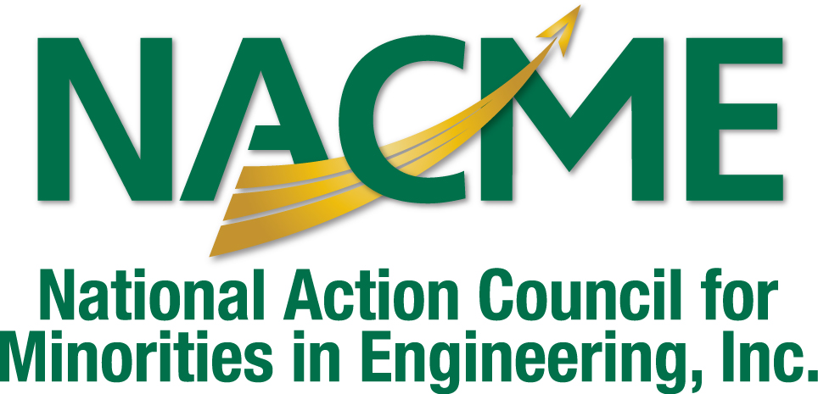

Cisco/NACME Scholarship Program

of the
National Action Council for Minorities in Engineering
Application Deadline: January 31, 2010

Our Invitation

We invite your application to the Cisco/NACME Scholarship Program, an exciting scholarship initiative that promotes minority student participation and achievement in computer science, computer engineering, electrical engineering, and mechanical engineering.

CISCO in Brief

Cisco enables people to make powerful connections-whether in business, education, philanthropy, or creativity. Cisco hardware, software, and service offerings are used to create the Internet solutions that make networks possible-providing easy access to information anywhere, at any time. Cisco was founded in 1984 by a small group of computer scientists from Stanford University.
Since the company's inception, Cisco engineers have been leaders in the development of Internet Protocol (IP)-based networking technologies. Today, with more than 63,050 employees worldwide, this tradition of innovation continues with industry-leading products and solutions in the company's core development areas of routing and switching, as well as in advanced technologies.

NACME in Brief

For nearly 30 years, The National Action Council for Minorities in Engineering, Inc. (NACME) has been privileged to support young African Americans, American Indians and Latinos in their aspirations to become engineers and scientists. Our alumni hold leadership positions in industry, medicine, law, education and government.

NACME is the nation’s largest private source of scholarships for African American, American Indian and Latino women and men in engineering. Over 12 percent of minority engineering graduates since 1974 have received scholarship support from NACME and are now leaders in government, industry, and academia. Through engineering, young people like you have discovered a world of opportunities.

Program Description

The Cisco/NACME Scholarship Program is an award of $5,000 towards the cost of your engineering education for one year. The scholarship rewards academic excellence and promotes achievement in an engineering and/or technical discipline.

Eligibility Requirements

Cisco/NACME Scholarship Program applicants must be:

- African American, Latino or American Indian

- Outstanding academic achievers (minimum grade point average 3.0/4.0)
- Junior or Senior
- Full-time enrollment in one of the following institutions:

Cornell University
Georgia Institute of Technology
North Carolina State University
Purdue University
Rensselaer Polytechnic Institute
University of Southern California
University of California, San Diego

Application Process

Please provide the following in your application package:

- Completed Cisco/NACME Scholarship Program Application
- Undergraduate Academic Transcript
- Letter of Recommendation
- Current Resume (using template)
- Essay Question

Scholarship recipients will be notified and must submit verification of full-time enrollment in an accredited engineering program.

We look forward to working with you. If you have any questions regarding this or other NACME scholarship programs, please feel free to email us at: msimpson@nacme.org. Please return your application to:
Scholarship Management, NACME, Inc.
440 Hamilton Avenue, Suite 302
White Plains, New York 10601-1813

Completed Applications must be postmarked by January 31, 2010

